GENERATION OF SINUSOIDAL WAVE USING PROTEUS

AIM:
To write an assembly language program to generation of sinusoidal wave using proteus using Proteus.
SOFTWARE REQUIRED:
- Proteus 8 Software.
PROGRAM:
; Main Program
ORG 0x000 ; Program start at address 0x000
GOTO start ; Jump to start of program
start:
; Initialize Registers
BSF STATUS, RP0 ; Select Bank 1
MOVLW 0x00
MOVWF TRISB ; Set PORTB as output
BCF STATUS, RP0 ; Select Bank 0
; Clear Variables
CLRF DAC_PORT ; Clear PORTB
CLRF index ; Clear index
main_loop:
; Output Sine Value to DAC
MOVF index, W ; Move index to W register
CALL get_sine_value ; Get sine value from table
MOVWF DAC_PORT ; Output sine value to DAC_PORT (PORTB)
; Increment Index
INCF index, F ; Increment index
MOVLW TABLE_SIZE ; Load TABLE_SIZE
SUBWF index, W ; Compare index with TABLE_SIZE
BTFSS STATUS, Z ; If index < TABLE_SIZE, skip next line
GOTO delay ; Else, jump to delay
CLRF index ; Reset index if at TABLE_SIZE
delay:
; Simple Delay Routine
MOVLW 0xFF
MOVWF delay_count
delay_loop:
NOP ; No Operation (adds small delay)
DECFSZ delay_count, F ; Decrement delay_count
GOTO delay_loop ; Repeat until delay_count reaches 0
GOTO main_loop ; Repeat main loop
; Subroutine to Get Sine Value
get_sine_value:
ADDWF PCL, F ; Add index to PCL to get sine value
RETLW 0 ; Return with lookup value in W register

END
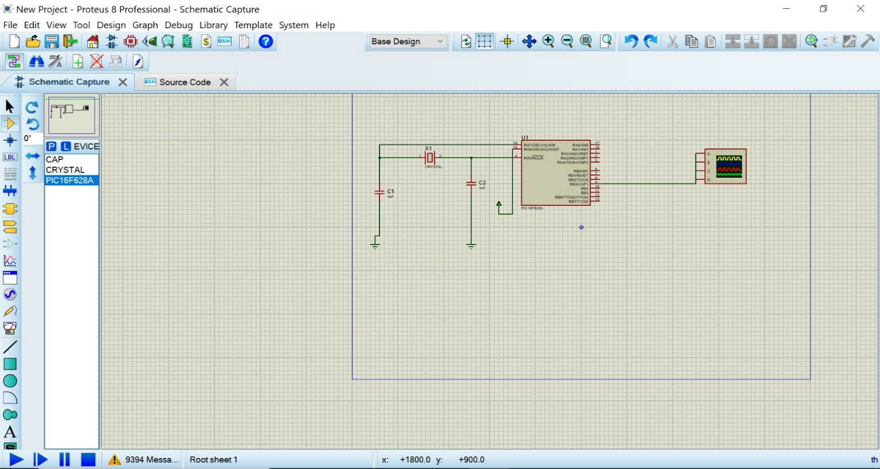
CIRCUIT DIAGRAM:

OUTPUT:
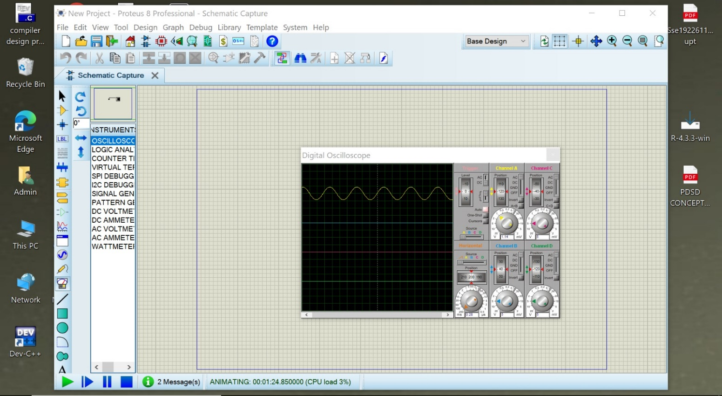
The Sinusoidal Wave is generated.

RESULT:
Thus, the program has been successfully verified and executed.

